

**UNITED INTERNATIONAL UNIVERSITY (UIU)**

Dept. of Computer Science & Engineering

Trimester: Summer 2024

Course No: CSE 4495 Title: Software Testing and Quality Assurance

Section: A Class Test-2

**Time: 30 minutes Marks: 20**

|  |  |  |  |
| --- | --- | --- | --- |
| **Name** |  | **ID** |  |

**Car Rental System**

A rental company loans cars (BDT 300), and bikes (BDT 100) for a day. This is the renting feature UI and the requirements are given below -   
**R1** The customer can add cars or bikes one by one to the rental order.  
**R2** The customer can remove cars or bikes one by one from the rental order.  
**R3** If the customer rents cars for more than BDT 600, then they can rent one bike for free. In case of discount:  
**R3a** If the customer has selected some bikes previously, then one of them becomes free.  
**R3b** If the customer hasn't selected a bike previously, then one free bike is added.  
**R4** If the customer deletes some cars or motorcycles from the order that the offering threshold doesn't hold, then any offering will be withdrawn.  
**R4a** When the discount is withdrawn but given again, and no bike was added meanwhile, the customer gets the previous discount back.  
**R4b** When the discount is withdrawn and some bikes are added when the discount is given again, then one of them becomes free.  
**R5** If the customer deletes the free bike, then no money discount is given. Adding the bike back the discount is given again by converting the bike price to zero.

Some Examples-

Initial state:

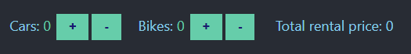

After renting 3 cars for 900BDT, 1 bike rent is added as discount

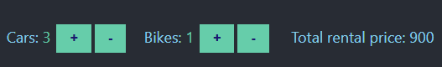

First Added 2 bikes and then 6 cars , 1 bike price was discarded.



Now for this system identify the choices, determine the representative values for those choices and evaluate the number of total specifications.